RECENT INTERNATIONAL ADDRESS OUTISIDE USA IF RESIDED DURING LAST 7 YEARS FOR REFERENCE :
ADDRESS: UD/LD:333, A – Colony, Dr. N.T.T.P.S, Ibrahimpatnam, Vijayawada, N.T.R District, AP 521456
LANDLINE NO:
MOBILE NO: 9290585989

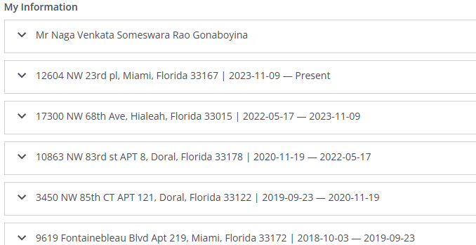

First Name: Naga Venkata Someswara Rao
Middle Name:
Last Name: Gonaboyina
Gender: Male
Phone No: 9379299592
Email ID: someswarao10@gmail.com
DOB: (MM-DD-YY): 06-10-93
Birth country: India
City: Seetanapalli
Birth State: Andhra Pradesh

Mother's Maiden Name: Gonaboyina
Father's Full Name:
Mother's Full Name:

Social Security Number: 657424170
Confirm Social Security Number: 657424170

Current Address:
Country: USA
Address 1: 12604 NW 23rd PL
Address 2:
City/Municipality: Miami
State/Region: FL
ZIP/Post Code: 33167
Period of Stay (From MMM/YY To MMM/YY): NOV/23 to till now

Address History (Last 7 years)
Address 1: 17300 NW 68th Ave
Address 2: Apt 117
City/Municipality: Hialeah
State/Region: FL
ZIP/Post Code: 33015
Period of Stay (From MMM/YY To MMM/YY): MAY/22 To NOV/23

Address History (Last 7 years)
Address 1: 10863 NW 83rd st
Address 2: Apt 8
City/Municipality: Doral
State/Region: FL
ZIP/Post Code: 33178
Period of Stay (From MMM/YY To MMM/YY): NOV/20 To MAY/22

Address 1: 3450 NW 85th CT
Address 2: Apt 121
City/Municipality: Miami
State/Region: FL
ZIP/Post Code: 33122
Period of Stay (From MMM/YY To MMM/YY): SEPT/19 To NOV/20

Address 1: 9619 Fontainebleau Blvd.
Address 2: Apt 219
City/Municipality: Miami
State/Region: FL
ZIP/Post Code: 33172
Period of Stay (From MMM/YY To MMM/YY): OCT/18 To SEPT/19

EDUCATION
Country: USA
Institution Name: Wright State University
Institution Type:
Address 1: 3640 Colonel Glenn Highway
Address 2:
City/Municipality: Dayton
State/Region: OH
ZIP/Post Code: 45435
Phone: (937)775-5512
Country Code: +1
Area Code/Phone Number: +1 9377755512
Qualification: Masters
Major/Field of Study: Electrical Engineering
Year Graduated: 2016
Start Date (DD/MMM/YYYY): 07/JAN/2015
End Date (DD/MMM/YYYY or Present): 30/APR/2016
Campus Location: 3640 Colonel Glenn Highway, Dayton OH 45435

EMPLOYMENT HISTORY
Employment (Last 7 years):
1
Country: USA
Job Type: Contract
Employer Name: Hive Soft Solutions
Address 1: 5851 Legacy Circle
Address 2: Suite 600
City/Municipality: Plano
State/Region: TX
ZIP/Post Code: 75024
Income Type:
Salary Currency:
Position Held:
Employee ID Number(must):
Contact Name: Venkat Avanigadda
Contact Email Address: venkat@hivesoftsoltuons.com
Contact Number: +1 945-400-3565
Position Held: President
Reason for Leaving:
Start Date (MMM/YYYY): JUL/18/2022
End Date (MMM/YYYY or Present): Present
Employer Location:

2
Country: USA
Job Type: Contract
Employer Name: Conquest consulting LLC
Address 1: 3000 polar lane,#803
Address 2:
City/Municipality: Cedar Park
State/Region: TX
ZIP/Post Code: 78613
Income Type:
Salary Currency:
Position Held:
Employee ID Number(must):
Contact Name: Gaddam Karthik
Contact Email Address: karthik@cqctek.com
Contact Number: +1 512-361-7204
Position Held: Hr Manager
Reason for Leaving:
Start Date (MMM/YYYY): APR/09/2018
End Date (MMM/YYYY or Present): JUL/15/2022
Employer Location:

Professional references - MUST
Please list individuals who are able to evaluate your capabilities. It’s best to include managers, or people that worked with or for you. Please don’t include personal friends or relatives.
1)First Name: Pranay
Last name: Lohkare
Designation: Manhattan Associate
Email id: pranay.lohkare@boeing.com
Contact no: +1 248-979-5163
Relationship type: Colleague

2)First name: Naga Venkata Siva Kumar
Last name: Yalamarthi
Designation: EDI Developer
Email id: nagavenkatasivakumar.yalamarthi@boeing.com
Contact no: +1 336-508-8839
Relationship type: Colleague
They should be aware that the hireright will contact them by next week.

Add additional employers if required with the same information as above.
Along with the above information need the below documents.
1. Authorization form (Attached to the email)(must)
2. Last 7 years of Employment Letter or Experience Certificate(must)
3. Highest Degree certificates - Diploma Certificate, Final Year Marksheet, Degree Certificate(must)

